CSCI251 Assignment 1
Ayken Lee Kang 1035289

Overview
The Weather Information Processing System I designed is able to perform all basic functionalities as listed in the assignment requirements. In this report, I will explain the thought process and execution behind each feature in the program, all the attempts and challenges along the way, and also solutions and implementations.

UML Diagram
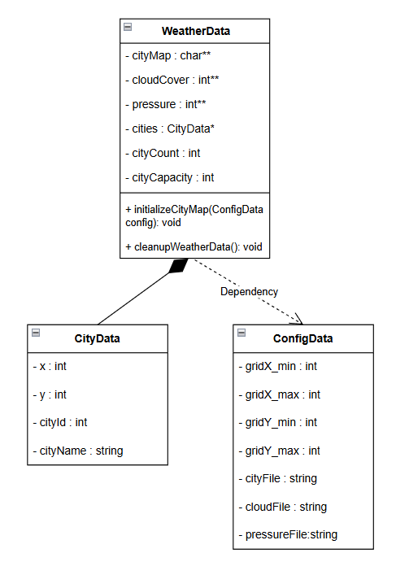

Feature I: Read a Config file

Implementation
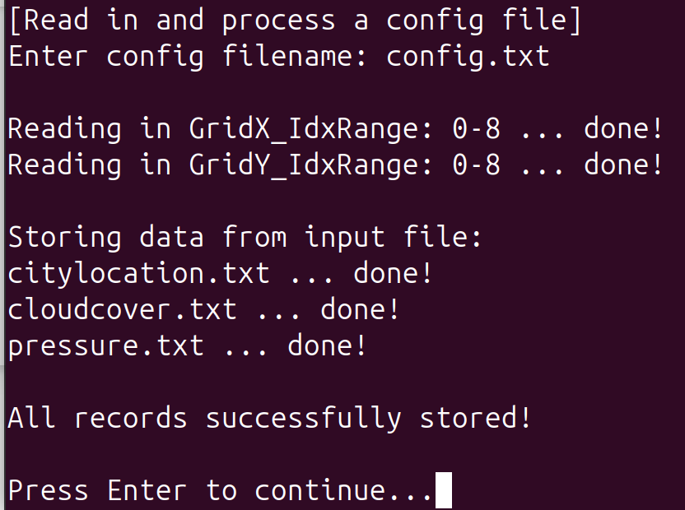
The program is designed to read config files that include the min and max values of the grid dimension, and also loading and processing the 3 types of files in config.txt which are citylocation.txt, cloudcover.txt, and pressure.txt. The program will process all the data and store them dynamically in a 2D array for the program to later display in the city map. One additional implementation was adding the “press enter to return to menu” after the program processes and stores the data from the files, as I felt that the user should be able to read and see that the storing of data from the config file was successful. Additionally, if this feature was not implemented , the menu would forcefully push the “successfully stored” message to the top, thus creating a minor inconvenience for the user as they would need to scroll up to read the messages.

Challenges
One assumption was that the file naming convention had to be fixed to citylocation.txt, pressure.txt etc. At this current stage, the program is only able to take in files with a fixed naming convention, and is not able to take in other files of different names. Another assumption was that the input files naming convention and data follow a very strict format. For example, citylocation.txt follows the [x,y]-id-name format. This would mean that there is no room for error when the user has to enter data into the text file, making it less flexible and in a way less user friendly.

Solution/Future improvements
The program will be more user friendly if it were able to take in input files without a fixed naming convention. One solution would be to implement whitespace tolerance, so that the program will still be able to read in the process the file despite an accidental whitespace input while typing in the terminal. However, having a strict naming convention is not all disadvantageous, as the program will be able to carry out the getline function easier, since the formatting of data is consistent throughout.

Feature II: Display City Map

Implementation
The program displays the city grid based on the min max value that is stored in config.txt. Program will find “GridX_IdxRange” and use the “=” and “-” as delimiters to find the values of min and max X. Once the program finds “=”, it will plus one to point at the value that is on the right side of the delimiter.

Challenges
One challenge was getting the alignment of the grid from the early interactions of the program. Since the whitespaces between the X and Y grids are not the same, it was tricky to figure out the exact spacing between each row and column to ensure that the map will be displayed consistently.

Solution/Future improvements
The solution to having a neater and accurate grid space was ensuring the calculations when initializing the grid was correct. The number of rows and columns were calculated by subtracting the min value from the max value, and adding 1. The additional 1 was to include the full range of the values provided. The cells within the grid were later initialized to a whitespace by default, creating the space within the map grid. The program will convert the coordinates in the .txt files to array indices, and will ensure that the program is able to store data dynamically, no matter what size the user inputs in the config.txt. Once program is able to calculate the max X and Y axis, it will print the “#” for the border and render row by row until the max value of Y is reached. Same thing will be done for the bottom border.

Feature III: Display Cloud Coverage Map (Cloudiness Index and LMH symbols)

Implementation
Once the map has been properly initialized, the program will extract the coordinates from cloudcoverage.txt and use the “,” as a delimiter to attain the X and Y values. First step was to ensure that the coordinates fall within the initialized grid boundaries. The program will then check if the cloud cover value is between the range of 0-100. If both criterias are met, the program will assign an index to the respective value in the getCloudinessIndex function. Program will initialize and print the map accordingly to the given grid space.

Challenges
One minor implication was the need of data validation, as the logic of the program depends on the predetermined ranges of cloudiness index. If data validation is not implemented, the program will display inaccurate information in the map, as values above 100 or below 0 will just reflect as 10 and 0 on the map respectively. During the first iteration of the program, the output of the map included a few white spaces as the indices were not properly assigned to the respective grid space.

Solution/Future improvements
The conversion of the raw data from cloudcoverage.txt to indices is crucial to ensure that the indices displayed on the grid are accurate. The program is designed such that it starts by processing the input line from the .txt file, and extracts the value that is after the “-”. Once the value is extracted, the program will assign and display the index on the coordinates of the grid. An important note of the program is that the original values are preserved and stored as raw percentages, and only converted to be displayed on the grid map. This will make the implementation of the cloud coverage LMH symbols, making it very flexible to changes. This also contributes to the program's efficiency as only one 2D array, which is the same size as the grid dimensions, is used.

Feature IV: Display Atmospheric Pressure Map (Pressure Index and LMH symbols )

Implementation
The overall design of this function is similar to the cloudiness index function, as it extracts the raw pressure value and stores it in a 2D array for the subsequent assigning of indices. Since the format of the data is the same as cloudcoverage.txt, the only change was storing the data in a new 2D array.

Challenges
Similarly to the cloudinessindex function, the vital component of the function not only to extract the data accurately, but to ensure that the necessary data validation was in place. The previous cloudinessindex function served as a test to ensure the input validation was correct, hence the problem of having inaccurate data displayed on the grid was not prevalent here.

Solution/Future improvements
One future improvement would be to implement a more robust index assignment, which allows the program to display even more intricate details of the data. For example, I could implement more indices to further divide the data into more subgroups. Values such as 32 and 36 could be assigned to index 5 and 6 respectively, creating even more accurate representation of data, despite the difference between the numbers being small. The same implementation can definitely be done for cloud coverage as well, further refining the accuracy of the program.

Feature V: Show Weather Forecast Summary Report

Implementation
The implementation of this module had many aspects as it involved more intricate calculations. The program is required to extract data and display them in a format such that it is easy for the users to comprehend. It collects and prepares the key datasets and presents them accurately, combining cloud coverage, pressure data and city information into predictions.

Challenges
The biggest challenge in this module was calculating the boundaries surrounding the cities, as those coordinates were required in order to calculate the rain probability. The issue with this was grouping the cities being rather complex, as the program had to identify the area that the city is occupying, and including the boundaries in the calculation. In addition to this, the program has to check if the boundaries are out of the grid space as well, which makes the logic of the module even more complicated. Another possible obstacle that the program has to overcome is when two cities share the same surrounding area. This could cause missing data points in the weather grid. The first few interactions of the module had to be hard coded as the size of the city was fixed to a specific size. However, I felt like it was very inefficient and would be quite unusable in certain scenarios.

Solution/Future improvements
The program begins by ensuring that all the required data is loaded before it begins the calculations. Then it will create a visited matrix to store coordinates that the program has already checked. This will fragment the cities into smaller groups which is easier for the program to understand. Next is to determine the area of the boundary by expanding the city bounds by 1 grid unit on each side. Once the program can determine the coordinates of the city and its boundaries, it will extract the relevant data from each coordinate and do the necessary calculations which are already predetermined. The program will take the result of the calculation and assign it a LMH symbol. With the 2 LMH symbols for ACC and AP, the program can then print the respective ASCII graphic below the report. This module really showcased the importance of data pre-validation as it prevented runtime errors, as well as the importance of memory management so that there is no data leak.

Reflection
Reflecting on the development process, the most significant lesson was the importance of procedural programming, as it allows the program to be fragmented into functions which will be easier to understand and utilise. Input validation also played a major role in the success of the program as it prevented runtime errors. Memory management in C++ requires a lot of attention as well to prevent the loss of data or depleting storage space . Future improvements could include real-time data APIs, multithreading for performance, and more weather metrics such as temperature and wind speed. This allows for more robust datasets to be represented in this program.

